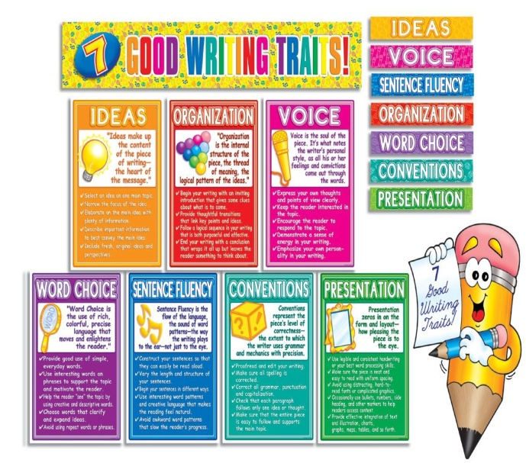
Web Resources Updated On 4/13/15
By: Larisa Weber

6+1 Trait Writing Poster Board

6+1 Trait Writing Activities
- Website 1
This website shows 8 different lesson plans on how to
incorporate all the traits of writing
- Website 2
This website is shown in a PDF and shows you
ideas, strategies, and activities
- Website 3
This website shows mini-lessons and examples of activities
to use in the classroom setting
- Website 4
This website has resources such as lesson plans, ideas, and
activities for primary age groups

Comprehension
- Website 1
This website is a great resource for teachers to let their students work independently on building their comprehension skills through activities. This link is designed for Pre-Kindergarten up to 6th grade. Simply pick the grade you wish to use this with, and then click on Language Arts. Once in Language Arts choose an online game or activity that is related to comprehension. The teacher can bookmark a page they wish the students to complete for easy access.

- Website 2
This website is a great resource link for teachers and parents. It has tips for parents in English and Spanish. It has comprehension activities for teachers and explains why comprehension is important when reading. There is an 8 minute video to watch of an example lesson on comprehension in the classroom. This website can be used for Kindergarten and up.

- Website 3
This website has activities for teachers and parents to use ranging from Preschool to 5th grade level comprehension. The activities are easy to follow by describing the activities, the materials needs to complete the activity, and step by step directions to do the activity.

- Website 4
This website has strategies to help teach comprehension for any grade level. It goes over the 6 comprehension strategies in depth and gives examples of activities to use.

- Website 5
This website contains comprehension skills, strategies & best practices to use for Kindergarteners through 8th graders. It introduces the meaning of comprehension and the types of strategies you can use when teaching a classroom. There are sample shared reading lessons and sample small-group reading lessons available for use.
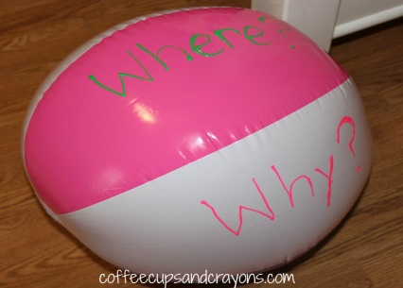
- Website 6
This website shows you how to create and use a question ball after reading a story aloud to the classroom. This helps the students increase their comprehension skills by asking questions. I would use this activity staring in 1st grade and up.

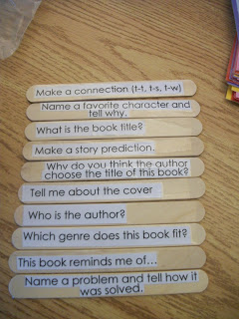
- Website 7
This website has a multiple different comprehension strategies for educators to use within their classroom. One activity that I really enjoyed was comprehension sticks. You use these sticks to ask some questions either BEFORE reading, some are DURING, and others are AFTER. You can use these at any grade level as long as you ask grade level appropriate questions.

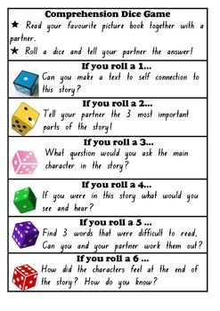
- Website 8
This is a Pinterest pin comprehension activity using dice. Students read a picture book in pairs. After reading, they roll a dice and the corresponding number instructs them to apply a certain comprehension strategy. I would use this in 2nd grade and beyond.

- Website 9
This website is a great resource for educators to print out and send home to parents. There is a free printable at home reading parent tip sheet. The sheet has information on choosing appropriate level books, helping a beginning reader, developing comprehension skills, and practicing fluency.

- Website 10
This website has an activity to help beginner readers become more aware of the books that are read to them by an adult. By asking your child or student simple questions, they will become better at reading comprehension.

Vocabulary
- Website 1
This website is a great resource for teachers to let their students work independently on building their vocabulary skills through activities. This link is designed for Pre-Kindergarten up to 6th grade. Simply pick the grade you wish to use this with, and then click on Language Arts. Once in Language Arts choose an online game or activity that is related to vocabulary. The teacher can bookmark a page they wish the students to complete for easy access.

- Website 2
This website can be a wonderful tool for educators to use. On the website it shares with you 11 tips on how to teaching common core critical vocabulary in the classroom. Tips can be uses for any grade of teaching.

- Website 3
This website is for teachers or parents trying to enhance a child’s vocabulary ability. There are 2 dozen tips and techniques for teachers or parents to use at home or in a classroom setting. Techniques are designed for Pre-Kindergarten to 8th grade.

- Website 4
On this Website there are plans and activities for teaching intermediate reading skills in elementary grades Kindergarten through 6th grade. There are multiple lessons on how to teach vocabulary, idioms, prefixes, and suffixes in a classroom.

- Website 5
This website contains over 1,000 free English vocabulary building games for students to play independently on the computers. The games are designed for Kindergarteners through 12th graders. Simply pick the grade level you wish to use this with, and then click on game you want to use. The teacher can bookmark a page they wish the students to use for easy access.

- Website 6
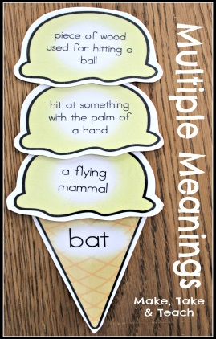
Parents or Educators can use this activity to help children remember certain vocabulary words. I love this idea of a vocabulary photo album and it is just an inexpensive dollar-store photo album and would make a great project for any content area you were teaching. Activity may be used in 1st grade and beyond.

- Website 7
This website would be great to help students learn the concept of how one can have a different meaning depending upon the words use in oral or written language. This activity can help students learn multiple meaning words and expand on their comprehension skills. The Ice Cream Scoops activity is a fun activity for expanding vocabulary by teaching multiple word meanings.
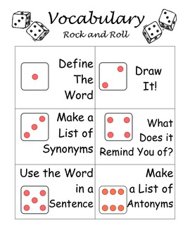
- Website 8
This website is a great resource for a center activity in your 1st, 2nd or 3rd grade classroom. This is a fun and helpful way for students to become more familiar with unit words or sight words. The activity consists of you rolling a dice to investigate new words and deepen their understanding. This is wonderful for workshop, centers, partners, or independent learning.

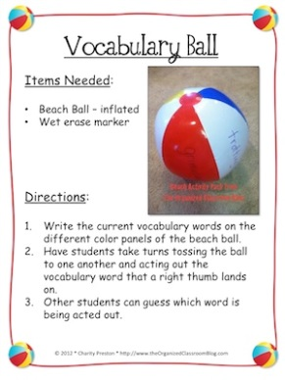
- Website 9
Vocabulary Ball Game Rules
Would use this activity in the classroom
starting in Kindergarten and beyond.

- Website 10
Great resource to find new and exciting
literacy games for the classroom or at
home. One of the games is similar to Musical Chairs - when the music stops, the students must be standing on a word and be able to say it and its meaning! They put the words on lily pads but you could put them on anything you would like. I would use this starting in Kindergarten and up.

Fluency
- Website 1
This website goes over how Readers Theatre Scripts are an important tool in helping children become fluent in reading. It goes over how to properly use Readers Theatre Scripts in a classroom setting. There are examples of scripts ranging from K-6th grade and in multiple content areas.

- Website 2
This website informs the teacher how to conduct Readers Theatre in the classroom. The script examples given are for grades K-3rd grade. The Scripts are all labeled and easy to print off for use.
- Website 3
This website has a lot of scripts that you can download and edit (optional). The scripts available range from grades K-6th grade. The website gives helpful tips when assigning students to a character.

- Website 4
This website is very user friendly through simple yet effective designing. They have a printer friendly button available on each script for simple printing. The scripts range from grade 1st-5th grade.

- Website 5
This website goes over the Readers Theatre and the benefits it has on the students’ fluency through oral reading. It talks about how to find scripts for the classroom and how to implement them through a 5 day process. There are scripts available ranging from K-8th grade.

- Website 6
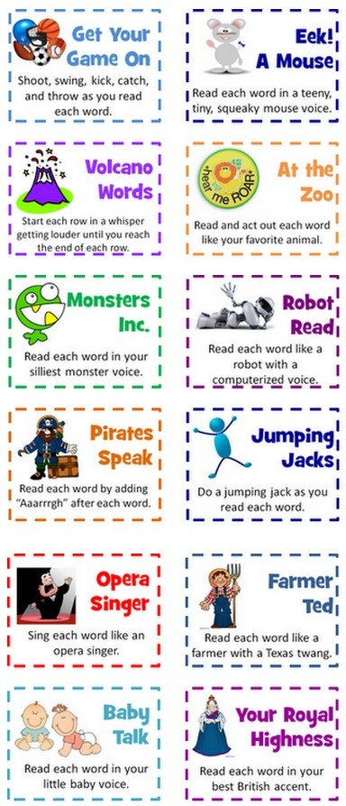
This website has a template for a voice Jar activity for building fluency through expression. This website does want you to pay $4 for their template but you can easily create your own. I can just imagine students loving this activity. I would start doing this activity in guided reading groups in kindergarten to bring more excitement to reading. I would also have older grades read independently through different expressions.

- Website 7
This website gives you activities you can implement within the classroom or at home. This activity you can work on expression and fluency by having the students read a paragraph after choosing one of these cards that gives them a different voice or action to do while reading. It keeps their attention while they are learning different ways to read. I would do this in grades 1st and up.

- Website 8
This website has a fluency basket activity. I would use this activity to help readers become more aware of their tone and expression. In the classroom, you can place fluency passages in a tub or basket for early finishers to grab and practice at their seats. I would use this activity starting in 2nd grade.

- Website 9
This website has print outs for readers theater for 1st grade through 3rd grade. There are also headbands for each student to wear that matches each character. This is a great tool to practice fluency and have positive social interaction with peers.

- Website 10
This website has a free Dr.Seuss Green Eggs and Ham Reader's Theater Book intended for the use of second graders. This book not only will help with fluency but it will also help the children become familiar with rhyming words.

Phonics/Phonemic Awareness
- Website 1
This website is a great resource link for teachers and parents. It has tips for parents in English and Spanish. It has phoneme awareness activities for teachers and explains why phonemic awareness is important for reading and spelling. This website can be used for Kindergarten and up.

- Website 2
This website is a great resource for teachers to let their students work independently on building their phonemic awareness through activities. This link is designed for Pre-Kindergarten up to 6th grade. Simply pick the grade you wish to use this with, and then click on Language Arts. Once in Language Arts choose an online game or activity that is related to phonemic awareness. The teacher can bookmark a page they wish the students to complete for easy access.

- Website 3
This website can be used by teachers and/or parents. The great thing about this website is that the teacher and/or parent can tracker the child’s progress. There are 5 different games that allow children to practice phonemic awareness skills through blending and segmenting words. These games would be appropriate for 1st graders and up.

- Website 4
This website has great activities for teachers and/or parents to use. These activities will help the children extend their phonemic awareness concepts and skills. These activities are designed for Kindergarteners and 1st graders.

- Website 5
This website is a great resource for teacher and/or parents. It first goes over the definition of phonemic awareness in length. It gives you 5 quick and simple activities to use with children to help build their phonemic awareness. These activities are designed for Pre-Kindergarteners to 1st graders.

- Website 6
This Website is a great resource link for teachers and parents. It has tips for parents in English and Spanish. It has phoneme awareness activities for teachers and explains why phonemic awareness is important for reading and spelling.

- Website 7
This online journal is a great resource to keep in your files. It breaks down what phonemic awareness is in simple, easy to understand terms. There are playful and interactive activities that focus on the sound structures of language to support students to develop their literacy.

- Website 8
This website is a great resource tool for parents and educators to come up with new and fun activities for the children. There is 20 Alphabet and Phonics Activities for kids. The lessons are fun, hands-on, and active ways to foster letter recognition, letter sounds, and phonemic awareness.

- Hohmann, M. (2002). Fee, fie, phonemic awareness: 130 prereading activities for preschoolers. Ypsilant, Michigan: High/Scope Press

This book has over 100 pre-reading activities designed for ages 2½ to 6. The activities are broken down into five content categories: identifying sounds, building rhyme awareness, building alliteration awareness, recognizing letters, and developing letter-sound awareness.

- Schickedanz, J. A. (1999). Much more than the ABCs. Washington, DC: National Association for the Education of Young Children.

This book offers strategies and activities to encourage phonemic awareness in children from birth on. The author has divided the chapters into age groups, giving key insight into development and what children can do at each stage. There are also suggestions for books and materials to use with students for each age range.

Study Skills

