**Materials for a Literacy Center**

**By: Larisa Weber**

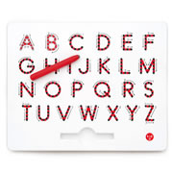

1. A-Z Magnatab Uppercase 🡪 🡪 🡪 🡪

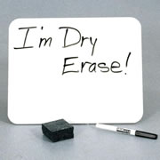

1. Dry-Erase Marker & Board 🡪 🡪 🡪 🡪
2. 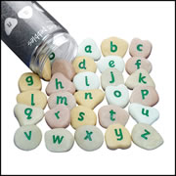Lowercase Alphabet Letters 🡪 🡪 🡪 🡪

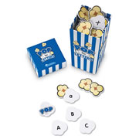

1. POP for Letters

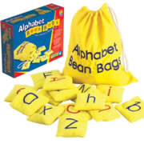

1. Alphabet Bean Bags 🡪 🡪 🡪 🡪

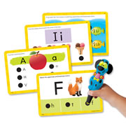

1. Hot Dots Jr. Alphabet Cards 🡪 🡪 🡪 🡪

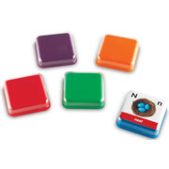

1. Talk Blocks Set of 5 🡪 🡪 🡪 🡪

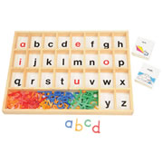

1. Alphabet Storing Tray

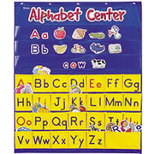

1. Alphabet Pocket Chart 🡪 🡪 🡪 🡪
2. 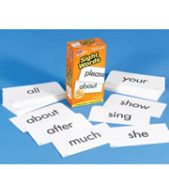 Sight Word Flash Cards 🡪 🡪 🡪 🡪

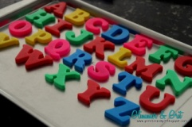

1. Magnet Tray & Letters 🡪 🡪 🡪 🡪
2. Tub with lid filled 1/3 up with salt to practice writing

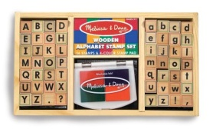

1. Stamp Letters 🡪 🡪 🡪 🡪

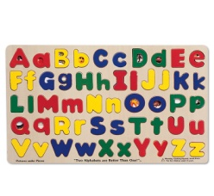

1. Letter Puzzle 🡪 🡪 🡪 🡪

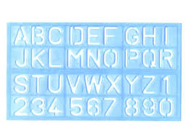

1. ABC Stencils 🡪 🡪 🡪 🡪

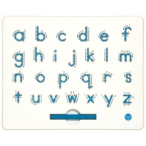

1. A-Z Magnatab Lowercase

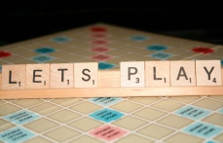

1. Scrabble 🡪 🡪 🡪 🡪

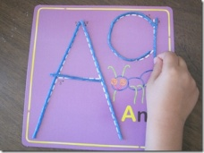

1. Wiki Sticks 🡪 🡪 🡪 🡪

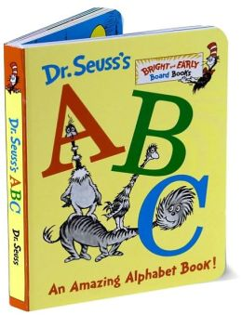

1. Alphabet Book 🡪 🡪 🡪 🡪

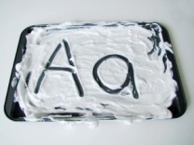

1. Shaving Cream Letters

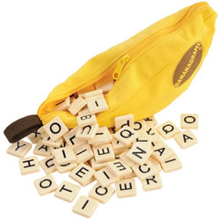

1. Bananagram Word Game 🡪 🡪 🡪 🡪