



**Annotated Bibliography**

**ECE 231**

**Larisa Weber**

Table of Contents

**Table of Contents**……………………………………………………………………….2

**Art**

Art Experiences for young children..……………………………………………………3

1-2-3 ART………………………....…………………………………………………..…….4

Story Time Arts and Crafts………………………………………………………………5

**Music**

Sing Along and Learn………………………..…………………………………...……...6

Sing Me a Story! Tell Me a Song!..........………………………………...……………..7

Sing Along and Learn: Early Concepts…………………………………………………8

**Drama or Creative Dramatics**

Story S-T-R-E-T-C-H-E-R-S for the Primary Grades...……………………..………..9

How to do Plays with Children………………………………………………………….10

Community Helpers………………………………………………….. …………………11

**Fingerplays**

Creative Resources for Early Childhood Classroom………………………………...12

Busy Fingers, Growing Minds.................................................................................13

The Bilingual Book of Rhymes, Songs, Stories, and Fingerplays ………………….14

**Puppetry**

Nursery Rhymes: Puppets, Patterns, and Props…………………………………….15

Alphabet Puppets from A to Z………………………………………………………….16

Alphabet Puppets…………………………………………………………………….….17

**Dramatic Play Centers or Prop Boxes**

Literacy Play Centers……………………………………………………………………18

Sensational Centers……………………………………………………………………..19

Hooray for Dramatic Play……………………………………………………………….20

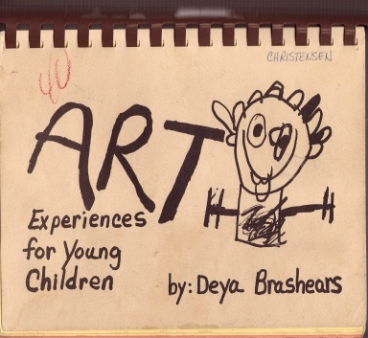

**Title**: Art Experiences for Young Children

**Author**: Deya Brashears

**Publisher**: Starlite Printing

**Copyright Date**: 1984

**Review**: This book is a great resource to have as a teacher. The book is easy to follow and full of simple hands-on activities for young children. The activities are broken down into 8 sections; painting, crayons, collage/sculpture, modeling materials, chalk, printing, holiday themes, and for fun. Every section is color coded for easy access. For each activity there is the title of the activity listed, the materials needed, and step by step procedures.

**Likely Use**: I would most likely use this in a preschool setting to give me even more ideas of fun projects I could do with the children. As a teacher it’s great to use resources so you can think smarter not harder.

**Sample Activity**:

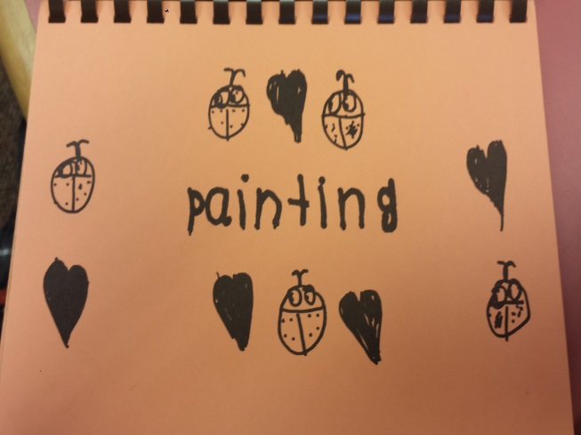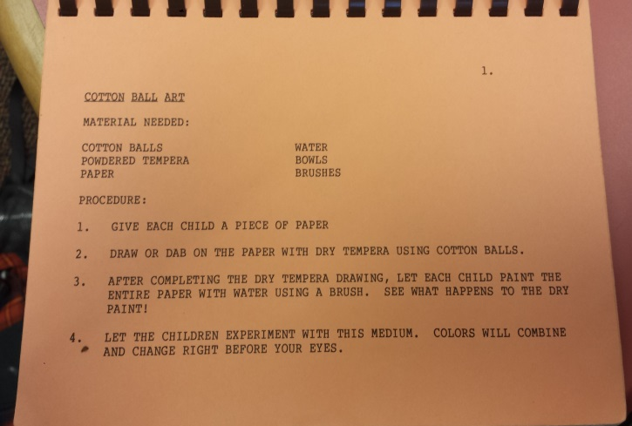

**Cotton Ball Art Activity**

This is an activity where children put dry tempera on a cotton ball to put on paper and then use a water brush to see colors mix and change.

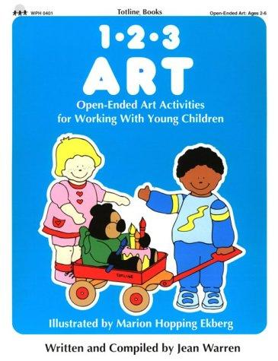**Title:** 1-2-3 ART

**Author:** Jean Warren

**Publisher:** Warren Publishing House, Inc.

**Copyright Date:** 1985

**ISBN Number:** 0-911019-06-5

**Review:** This is a great resource if you are trying to think outside of the box when it comes to art lessons. This book gives you at least 25 lessons on how children can paint with and on different materials, ranging from feathers to egg cartons. 1-2-3 art is easy to navigate thanks to the contents, titles of lessons, and page numbers. In this book it also includes art activities in gluing and modeling with a lot of different materials for each. It is great to switch up art activities for the students and incorporate materials they may have never seen before. Art is all about experimenting with new materials!

**Likely use:** I would likely use this book in preschool or at a kindergarten art center to give my students a variety of options on how to do art activities.

**Sample Activities:**

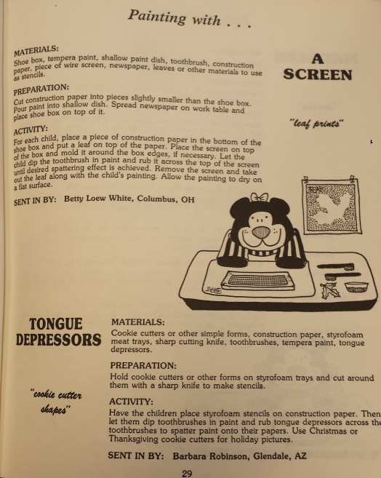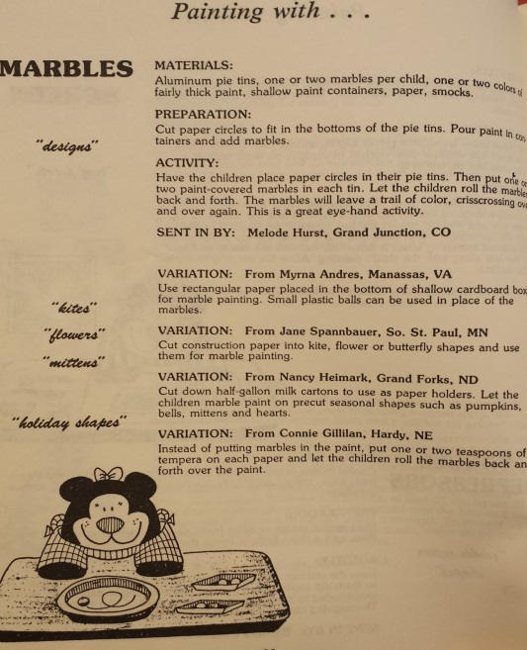

[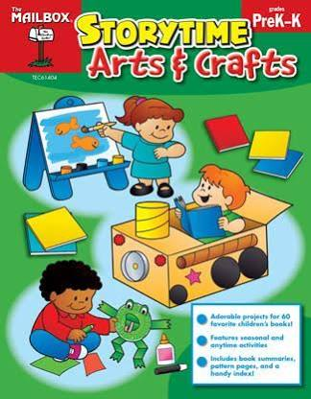](https://www.google.com/shopping/product/5510014069174753534?q=Storytime+Arts+and+Crafts&biw=1440&bih=601&bav=on.2,or.r_qf.&bvm=bv.81456516,d.aWw&tch=1&ech=1&psi=FIOIVKH7Oo2pyATgkIDYCg.1418232597437.5&prds=paur:ClkAsKraX5jUj5h0Z0rXsRU6RVb6EYRaAjj64ROHBPcPyZSh0uU82cfbQo-5U3QgP17zX7RDqPVXeOzVUJqELIXiZ6KHz99gnmyX_iirze9Kw0J9QQCuAFLIyhIZAFPVH72GR8NR2w_8tmDxQvfbq9PfSMEXww&ei=GoOIVJGXKIugyQSW1oLYDw&ved=0CGoQqSswAA)**Title:** Storytime Arts & Crafts

**Author:** The Mailbox Team

**Publisher:** The Mailbox Books

**Copyright Date:** 2013

**ISBN Number:** 9781612763675

**Review:** This book was easy to look through and it was neat to see how they tied books together with certain crafts. This book is aimed for children in Preschool and Kindergarten but you could use this book with resource students and older students if modified to fit standards. I saw multiple story books that I was familiar with such as *Brown Bear, The Mitten, and The Hungry Caterpillar.* All of these arts and craft projects have a purpose and related to the story that was read.

**Likely Use**: I would likely use this with students in Kindergarten to make crafts that resemble the story we read in a whole group setting during art center time.

**Sample Activities:**

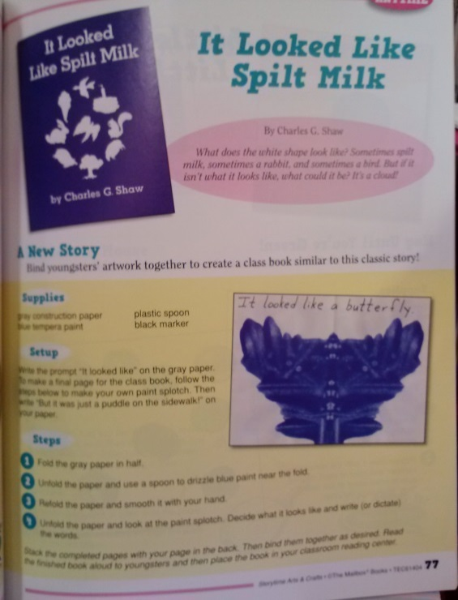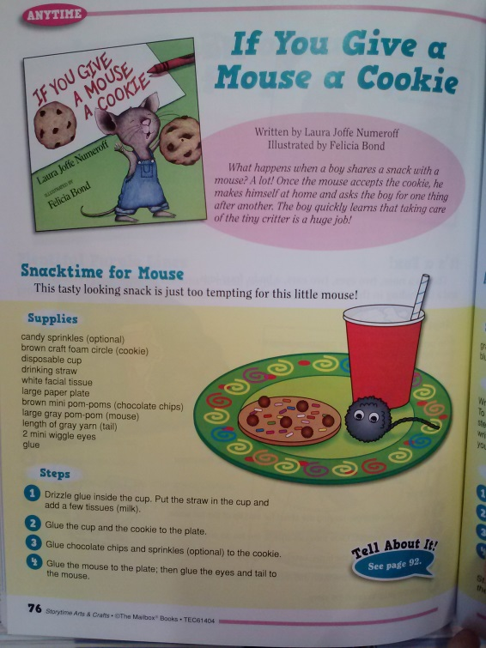

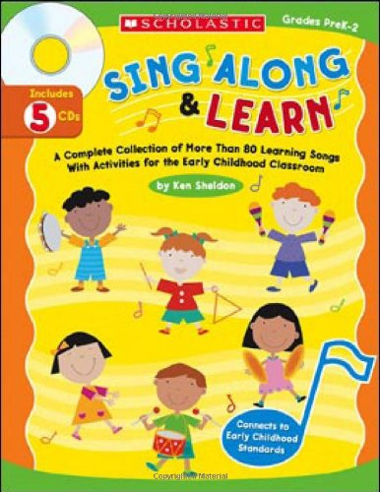

**Title:** Sing Along and Learn

**Author:** Ken Sheldon

**Publisher:** Scholastic, Inc.

**Copyright Date:** 2006

**ISBN Number:** 9780439609777

**Review:** This *Sing Along and Learn* is for children in preschool through second grade. This book has 80 learning songs with activities for children to get moving. There are lessons in movement, language development, and math. 5 CD’s come along with this book so no need to buy anything but the book for the activities.

**Likely Use:** I can see myself using this book to help with songs for calendar time at the Preschool or Kindergarten level. There is a wonderful ABC song, one for days of the week, and the months of the year.

**Sample Activity:**

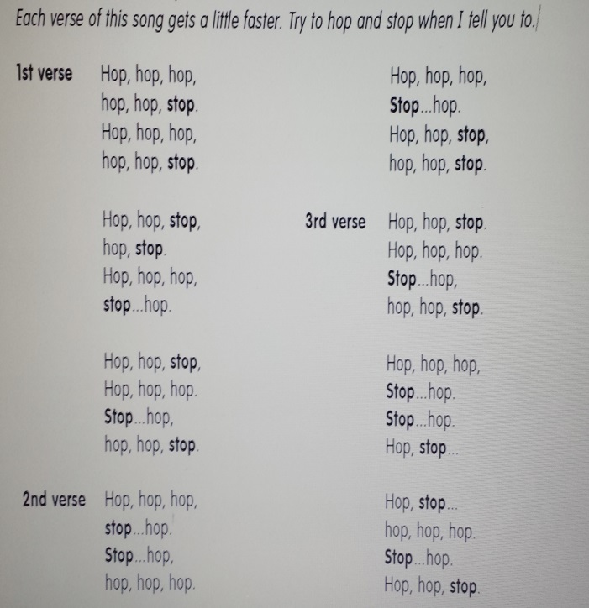

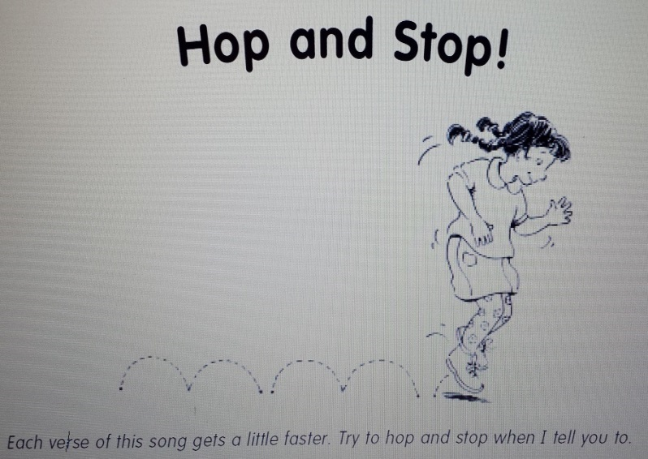

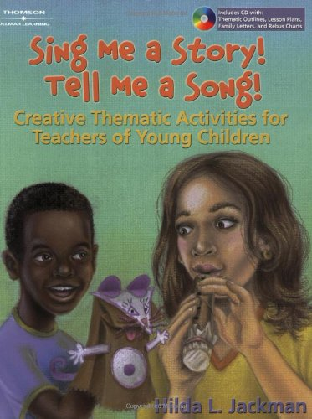**Title:** Sing Me a Story! Tell Me a Song

**Author:** Hilda L. Jackson

**Publisher:** Wadsworth Publishing

**Copyright Date:** 2005

**ISBN Number:** 9871602680197

**Review:** In this book there are 30 thematic units with goals in each activity. Activities consist of finger plays, poems, music and movement, and creative food experiences. The book’s layout is easy on the eye with pictures and colorful pages. By each activity, there is a picture of the age group it is appropriate for. This book ranges from infant activities to primary grade activities. This book also comes with the CD!

**Likely Use:** I would mainly use this in a Preschool or daycare setting during transition time for music we can sing as a whole and do movement activities with.

**Sample Activities:**

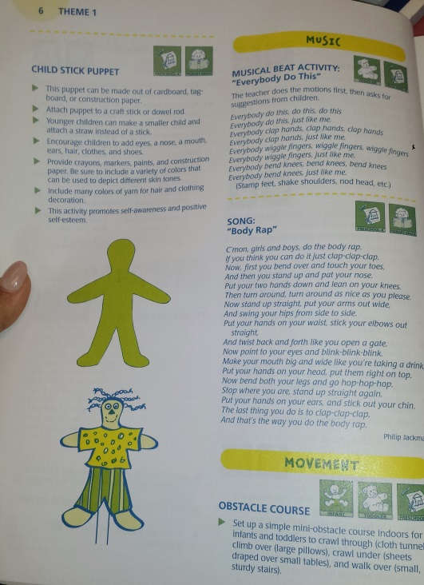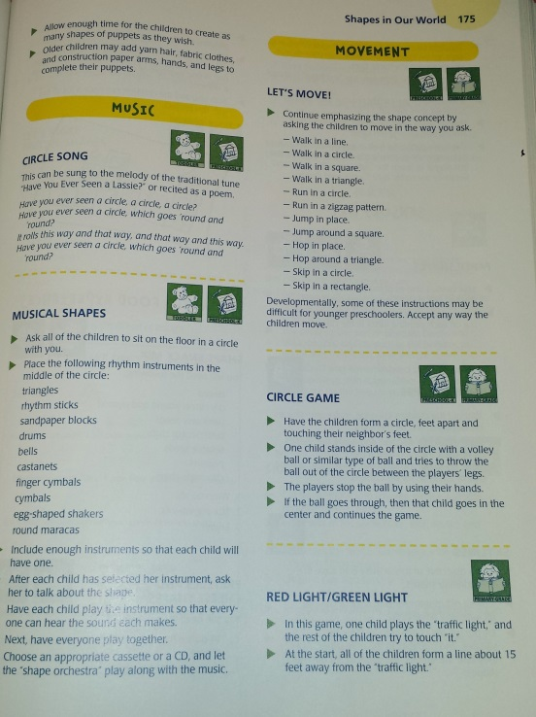

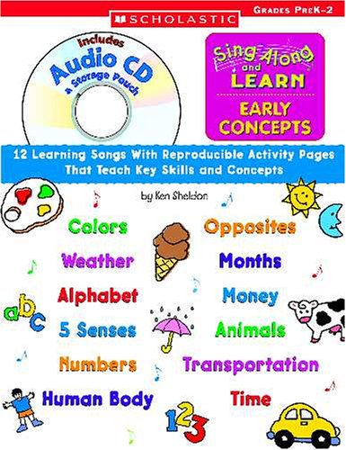**Title:** Sing Along and Learn: Early Concepts

**Author:** Ken Sheldon

**Publisher:** Scholastic, Inc

**Copyright Date:** 2004

**ISBN Number:** 9780439665391

**Review**: This music book has 12 learning song with reproducible activity pages that can teach children skills and concepts that are grade level appropriate. The book comes with a CD of each song with a variety from ABC’s to Animals. This book is designed for Pre-Kindergarteners to 2nd graders. This is definitely on my Christmas list because I can see myself using this a lot with students.

**Likely Use**: I would likely use this book with preschoolers or kindergartners throughout the day in math when we talk about money or in science to help remember human body parts.

**Sample Activity**:

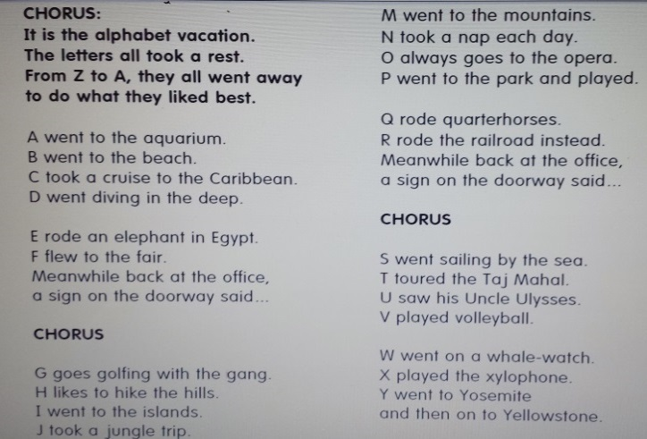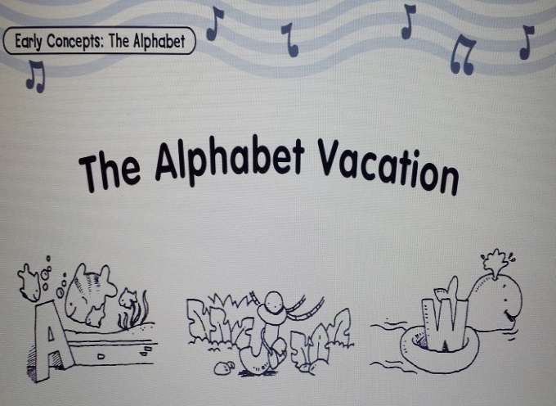

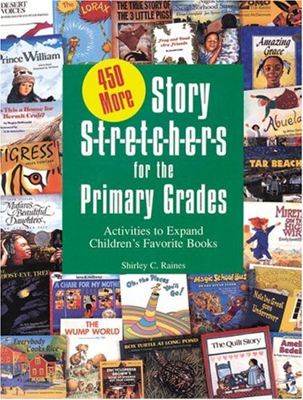

**Title:** Story S-T-R-E-T-C-H-E-R-S for the Primary Grades

**Author:** Shirley C. Raines & Robert J. Canady

**Publisher:** Gryphon House, Inc.

**Copyright Date:** 1992

**ISBN Number:** 0-87659-157-8

**Review**: The book is kind of scary when you first open it up because there are no pictures except the story book you are going to stretch upon. It is not that scary once you look at the context the pages have to offer. It tells you the book you can read to the call along with read-aloud suggestions. Once you are done reading the book aloud there are at least 5 different ways you can stretch out the story into an activity. You can strength the book by creating a creative dramatic by adding dialogue.

**Likely Use**: I would mainly use this with third graders. I would use any of the stretcher activities after reading a book aloud to the class in a whole group setting.

**Sample Activity:**

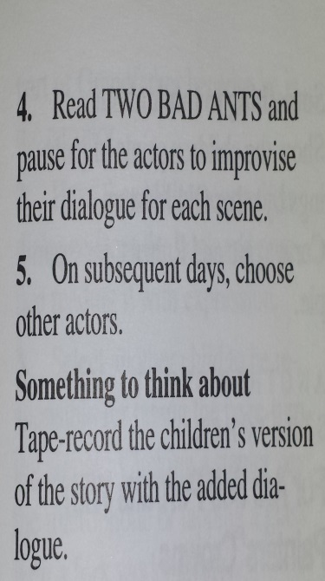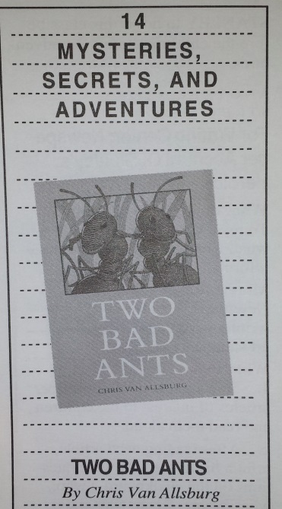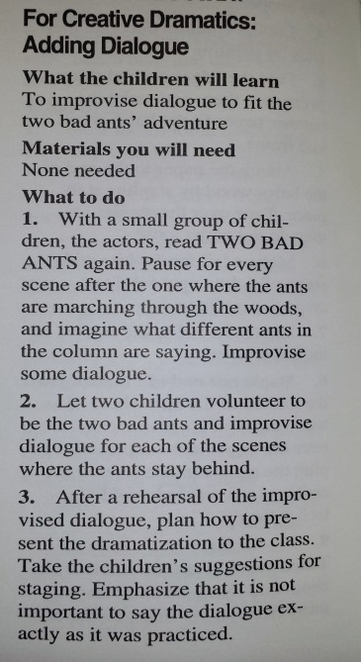

The Book Part One Part Two

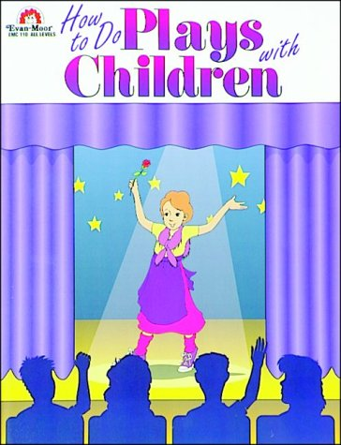**Title:** How to do Plays with Children

**Author:** Jo Moore, Ginny Hall,

Leslie Tryon, and Betsy Franco

**Publisher:** Evan-Moor Corp.

**Copyright Date:** 1994

**ISBN Number:** 9781557993328

**Review**: Overall, this book is a must have for any teacher trying to create a play with children involved. It has plenty of play ideas that teachers can utilize, the lines for each character in the play, props, and much more! This book makes it easier on to find roles for each kid, whether he/she is a quiet or outgoing personality. Plays allow children to express their creative sides and possibly show them a subject they will want to do in the future. The book has three sections; the rhyming plays, the folk tales, and the readers theatre. Something I enjoyed about the book was that it could be used with all age groups and skill levels. This allows the teacher with the flexibility needed in order to meet their students’ needs.

**Likely Use**: I would use this book to help me come with creative ways on how to do plays in a classroom setting.

**Sample Activities**:

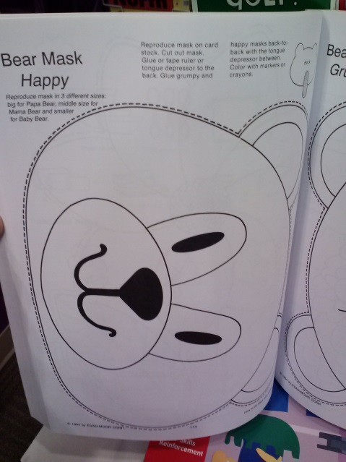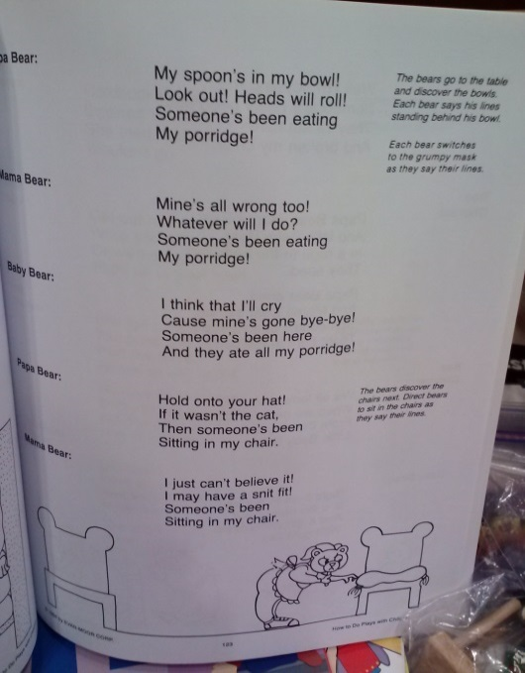

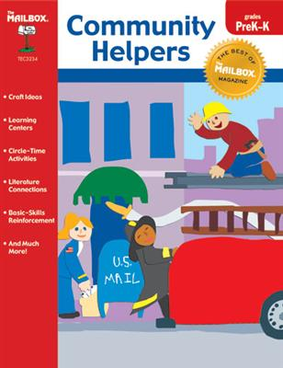

**Title:** Community Helpers

**Author:** The Mailbox Team

**Publisher:** The Mailbox Books

**Copyright Date:** 2002

**ISBN Number:** 9781562344962

**Review**: This community helpers book is the perfect way to introduce kids in the classroom to inspirational people in the community. Written more along the lines of a magazine, it is full of excellent resources to help the children learn and be able to help their community. The book also provides great ways that kids can be community helpers in the classroom. The book does a wonderful job at covering some of the most well-known types of community helpers, like a referee, to less well known type of community helpers that expand the children’s horizons on what and how they can help out.

**Likely Use**: I would use this to help introduce students to inspirational people in the community and their duties.

**Sample Activity**:

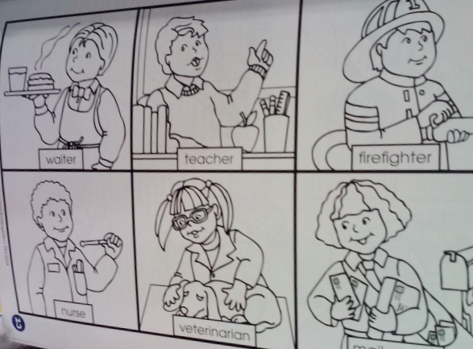

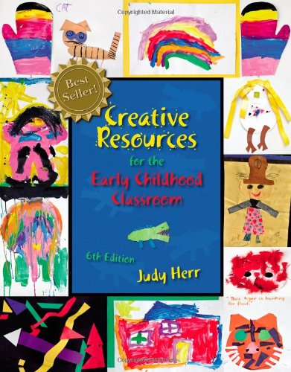

**Title:** Creative Resources for Early Childhood Classroom

**Author:** Judy Herr

**Publisher:** Cengage Learning

**Copyright Date:**

**ISBN Number 13:** 9781111831028

**Review**: This book is the whole package and can be used for multiple activities other than fingerplays and chants. This is a great resource to help plan daily curriculum and classroom activities. Judy Herr has this book organized in alphabetical order so it is easy to find what you are looking for. There are multiple themes and in each theme it contains goals, and concepts for children to learn throughout the themed lessons.

**Likely Use**: I would use mainly use this in the Preschool setting and some other activities just as the chants I would use put to 1st grade.

**Sample Activity:**

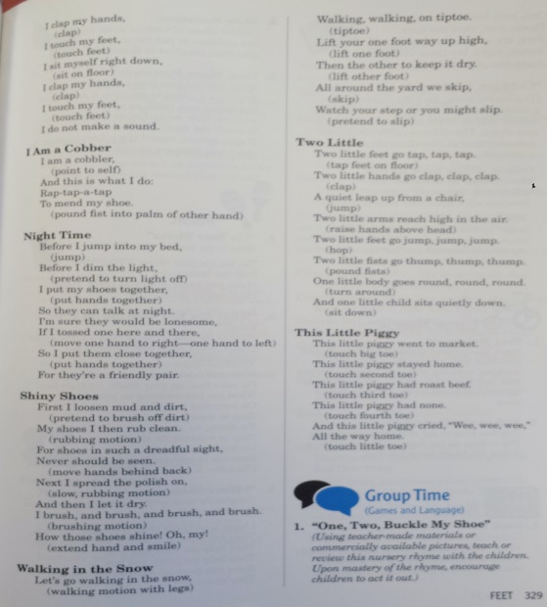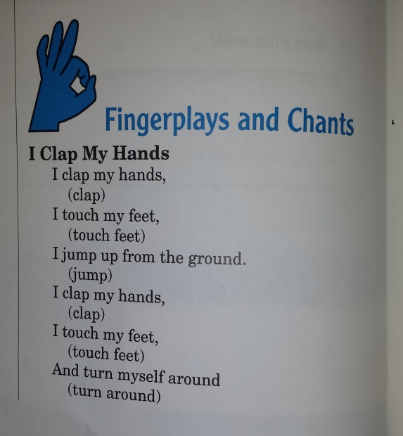

Page 1 of 2 - Fingerplays & Chants Page 2 of 2 – Fingerplays & Chants

[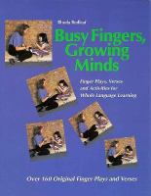](http://gapines.org/opac/extras/ac/jacket/large/r/755376)

**Title:** Busy Fingers, Growing Minds

**Author:** Rhoda Redleaf

**Publisher:** Redleaf Press

**Copyright Date:** 1993

**ISBN Number:** 9780876592809

**Review**: This book is a gold mine of great resources on how to make language development fun for children. There are over 160 original fingerplays and verses throughout the book. I really enjoy how the books fingerplays and verses are about things children tend to enjoy like animals and babies. I really like how the table of contents is organized for easy use. This book is all in black and white so it does seem a little boring at first glance but it is full with excellent fingerplays with a variety in themes.

**Likely Use**: I would most likely use this book when working in a Preschool or Kindergarten setting.

**Sample Activity**:

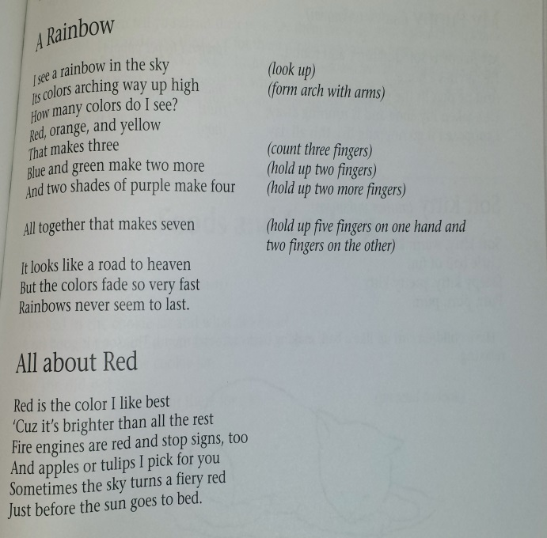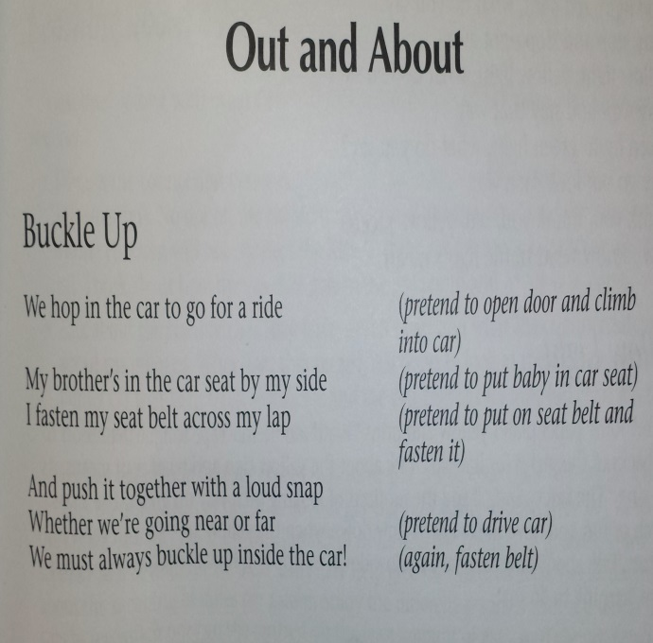

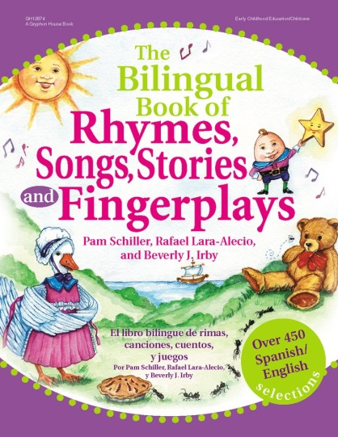

**Title:** The Bilingual Book of Rhymes, Songs, Stories, and Fingerplays

**Author:** Pam Schiller, Rafael Lara-Alecio, & Beverly Irloy

**Publisher:** Gryphon House, Inc.

**Copyright Date:** 2004

**ISBN Number:** 9780876592847

**Review**: There is a collection of over 450 rhymes, songs, stories, and fingerplays range from preschool to second grade. There are Spanish and English on each page and is organized by theme for easy teacher use. This is a great learning tool to help teach children new vocabulary and review already taught vocabulary.

**Likely Use**: I would most likely use this in a classroom where I am trying to teach students a little bit of Spanish dialect or need to help an ELL native Spanish speaker with translating certain words for them to better understand what is being said/sang in English.

**Sample Activity**:

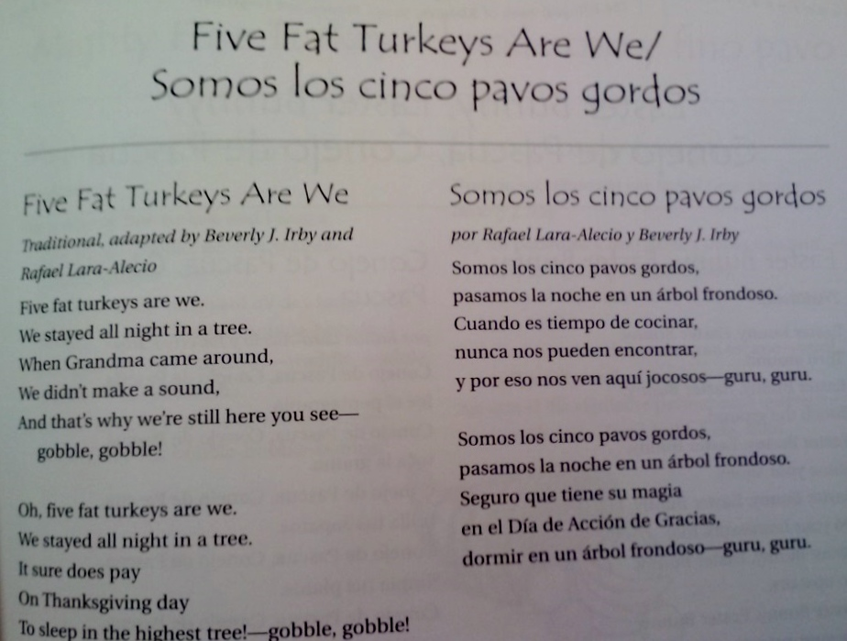

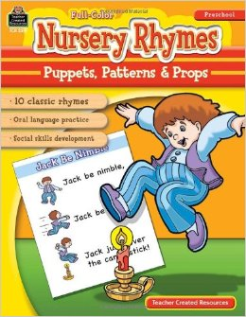

**Title:** Nursery Rhymes: Puppets, Patterns, and Props

**Author:** Holly Burns

**Publisher:** Mary D. Smith

**Copyright Date:** 2008

**ISBN Number:** 9781420623192

**Review**: This book caught my eye with its cover one of my favorite nursery rhymes, Jack be nimble. The book contains all the classic nursery rhymes that kids grow up hearing. It teaches you how to use the cutouts to make a puppet show theatre. Young kids would be attracted to this book due to the pictures of the characters they love. It is designed for children ages preschool- first grade. Puppet shows have the ability to develop children’s language development, social development, and imaginations.

**Likely Use**: I would use in a classrooms setting to help me come up with ideas on how to made a puppet theater.

**Sample Activities:**

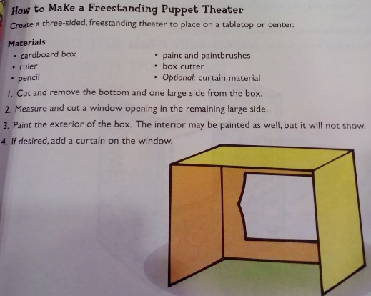

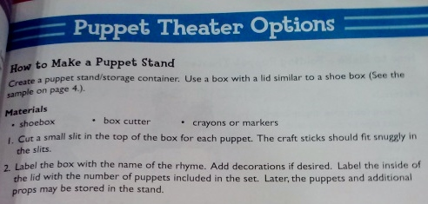

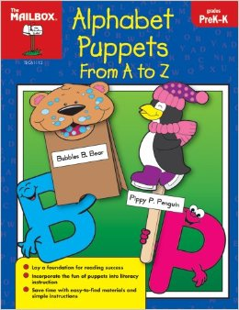

**Title:** Alphabet Puppets from A to Z

**Author:** The Mailbox Team

**Publisher:** The Mailbox Books

**Copyright Date:** 2008

**ISBN Number:** 9781562347994

**Review:** This book provides great interactive ideas on how kids can be creative and create puppet friends. Every letter of the alphabet gives the kids three fun activities to have fun with. One thing to keep in mind is that the materials for the activities is not provided with the book, but the ideas for creating puppet friends and learning the letters of the alphabet are very useful and fun. Another fun thing is that none of the images are colored in so that gives the teacher and students another way to have fun and be creative as they fill in the images with color. This is a fun book for kids that helps them learn their alphabet.

**Likely Use**: I would use the ABC activities to help students become more familiar with the letters or to help review letter sounds.

**Sample Activity**:

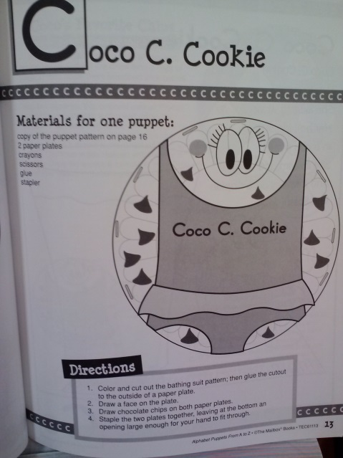

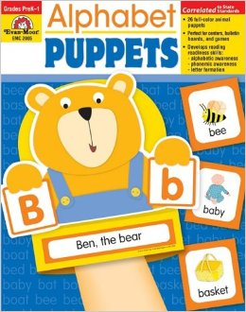

**Title:** Alphabet Puppets

**Author:** Joy Evans and De Gibbs

**Publisher:** Evan Moor Educational Publishers

**Copyright Date:** 2009

**ISBN Number:** 9781596734258

**Review:** This great book will help children from age’s three to seven with their alphabet. It not only helps kids learn the alphabet but also covers phonemic skills and letter formation. As an example, for every letter it has the letter, how to sound out the letter and the proper way to write the letter. The book also provides a blank space to practice letter formation and some cut out cards that help the kids learn and hints on the cut out card to help remember the letters. The books even provides a colorful puppet cut out that also helps remember the letter which can be glued onto construction paper.

**Likely Uses**: I would use the ABC activities when introducing a new letter to the classroom or when reviewing a letter.

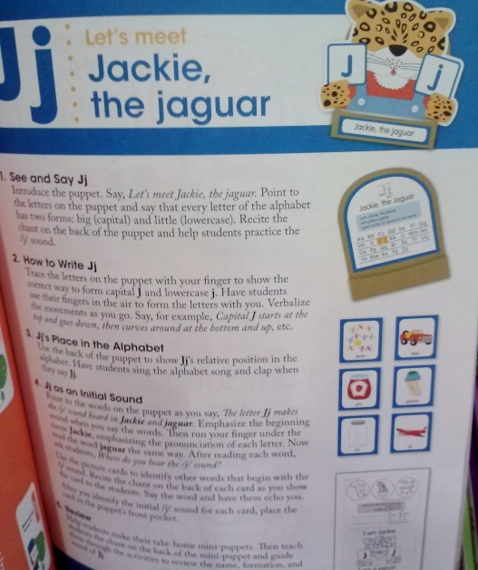**Sample Activity:**

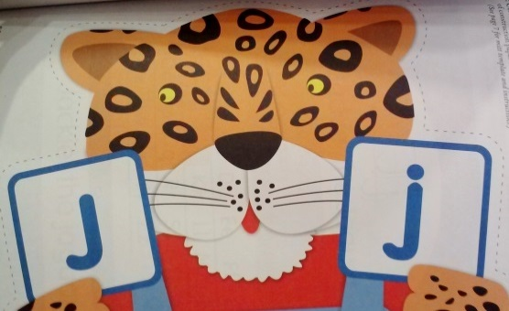

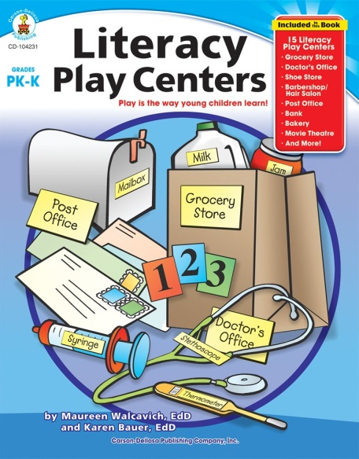**Title:** Literacy Play Centers

**Authors:** Mauren Walcavich and Karen Bauer

**Publisher:** Carson-Dellosa Publishing

**Copyright Date:** 2007

**ISBN Number:** 9781594417849

**Review**: This book provides an excellent and highly interactive way to have preschoolers and kindergarteners learn. The great thing about this book that it has centers for the kids, it lists all the materials that will be needed, goals for the children at each center and also lists of books that are relevant to each center focus of topic. It even goes into detail on how to have the most successful center, making sure that the kids and teacher will be getting the most out of creating and learning from each center the book provides an idea for. Centers can be focused around a shoe store, post office or a movie theater for example and it covers a wide range of curriculum such as science, math, writing, and reading.

**Likely Use**: I would use this when I need to come up with different ideas for a new center for my students.

**Sample Activity**:

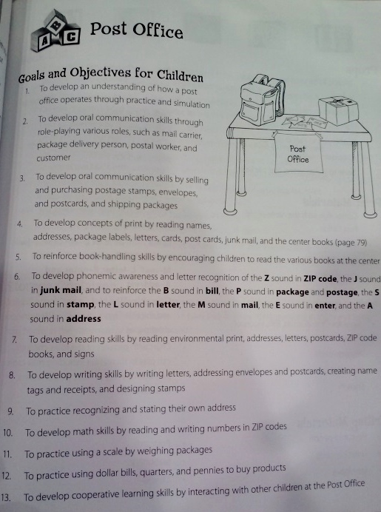

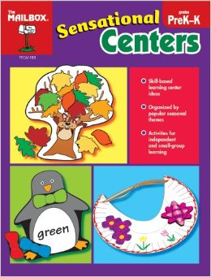**Title:** Sensational Centers

**Authors:** The Mailbox Team

**Publisher:** The Mailbox Books

**Copyright Date:** 2008

**ISBN Number:** 9781562348533

**Review**: This book is title properly as it provides unique, fun and catch's your attention. I would recommend this one to my fellow teachers or parents. It is unique in the sense that the centers are broken down into the different season around the year. One example would be that in February, the center would be focused on the post office as the children can create and mail each other cards for Valentine's Day. Around the holiday season, the center would focus on a bakery as the kids could bake Christmas cookies! I have a feeling that the kids would really like the centers based around the season so they can have fun and practice different skills. The books also provides ideas for a center of a vet clinic with very specific activities for a horse clinic. The book being based on the seasons and providing unique center are a great way for kids to learn.

**Likely Use**: During the holiday times, I would use this book in my classroom.

**Sample Activity**:

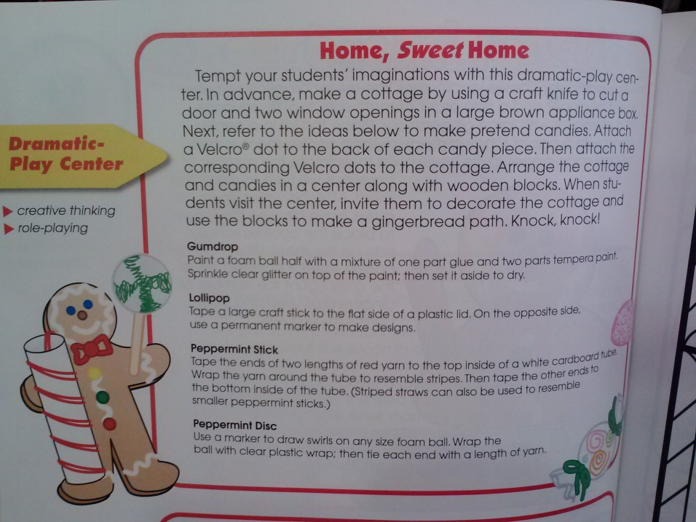

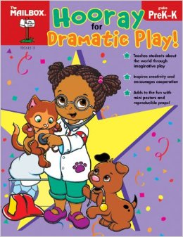

**Title:** Hooray for Dramatic Play!

**Authors:** The Mailbox Team

**Publisher:** The Mailbox Books

**Copyright Date:** 2011

**ISBN Number:** 9781562349783

**Review**: This book is full of colorful page set-ups and ideas. The dramatic play centers in this book are very creative and original. Some examples of these centers would be a pet shop that you can see in more detail in the sample activity below and an ice cream shop center. The centers in this book are new ideas that would intrigue children partake in dramatic play. This book main target is for Preschoolers to Kindergarteners.

**Likely Use**: I would use this in my classroom to switch up my dramatic play center monthly so the children can experiment with new materials.

**Sample Activity**:

